Name:k.kamesh

Date:31/08/2023

Math pow() method:

The [java.lang.Math](https://www.geeksforgeeks.org/java-lang-math-class-in-java-set-1/).pow() is used to calculate a number raise to the power of some other number. This function accepts two parameters and returns the value of first parameter raised to the second parameter. There are some special cases as listed below:

* If the second parameter is positive or negative zero then the result will be 1.0.
* If the second parameter is 1.0 then the result will be same as that of the first parameter.
* If the second parameter is NaN then the result will also be NaN.
* The function java.lang.Math.pow() always returns a double datatype

Syntax:

public static double pow(double a, double b)

Parameter:

a : this parameter is the base

b : this parameter is the exponent.

Return :

This method returns ab.

Example:

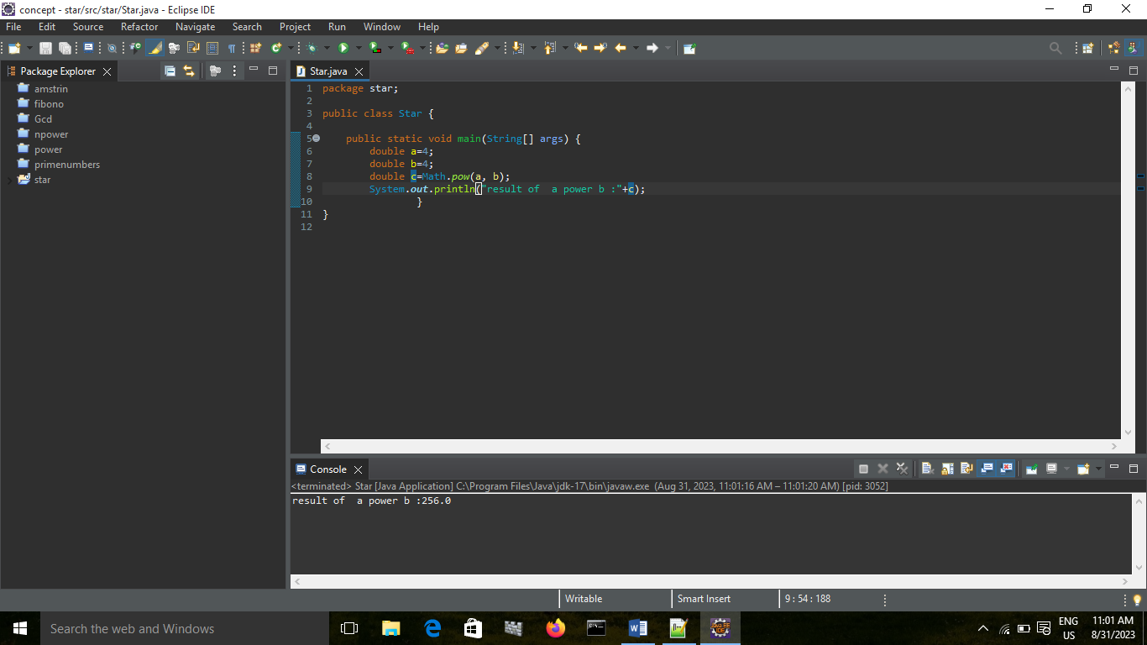

Random():

The java.lang.Math.random() method returns a pseudorandom double type number greater than or equal to 0.0 and less than 1.0. When this method is first called, it creates a single new pseudorandom-number generator, exactly as if by the expression new java.util.Random.

Declaration of Java Math random():

Below is the declaration of java.lang.Math.random() method is mentioned below:

public static double random()

Return Type:

This method returns a pseudorandom double greater than or equal to 0.0 and less than 1.0.

Example:

